Advanced Scripting   
PowerShell

Last Updated: 12/23/2022 9:13 AM Version 1  
Document Prepared for: CIT361 Student

# Name Daniel Harris ID 235868292

# Instructions

Save a copy of this document. Answer all questions directly in this document. You will save and upload this completed document as your homework submission.

# Overview

Learn how to launch PowerShell in both normal user and administrative mode. Pin PowerShell to the taskbar to make it easily accessible. Learn how to find PowerShell version.

# Setup

You will need Windows to do this Exercise. If you do not use windows as you main OS setup a Windows VM. You probably already have one.

# Task 1—Launching PowerShell

Since PowerShell has been built into Windows since Vista all you need to do is launch it. There are several ways to launch PowerShell

## Steps

1. Launch PowerShell using the start menu.
   1. Click on the start menu or press the Windows key on your keyboard.
   2. Start typing PowerShell. When you see the PowerShell link click on it.  
      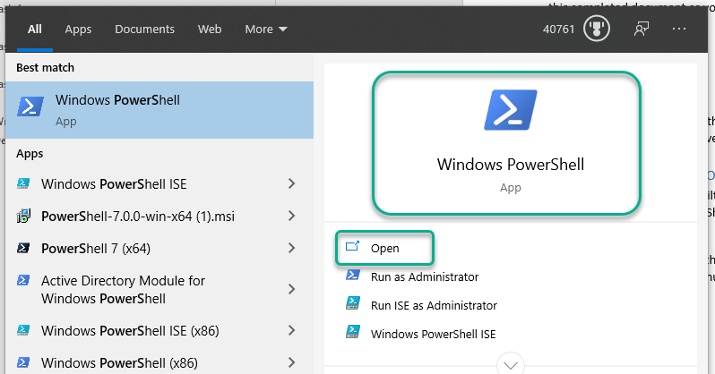
   3. You Should see the PowerShell console  
      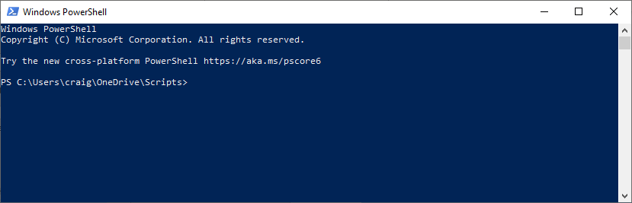
   4. Enter the following command in PowerShell:  
      **$PSVersionTable**
      1. What is the PSVersion? 5.1.22621.169
      2. What is the PSEdition? Desktop
2. Now launch the administrative shell. For this to be successful you will need administrative privileges on your system.
   1. From the Start Menu type PowerShell. This time when you see the PowerShell link click on the **Run as Administrator** link  
      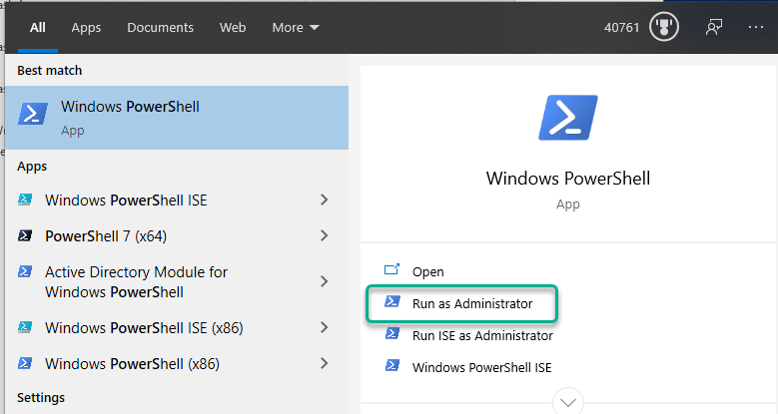
   2. After you accept the UAC you should see the PowerShell console. Notice the title now says Administrator: Windows PowerShell
      1. Take a screenshot of your administrative shell and paste it below  
         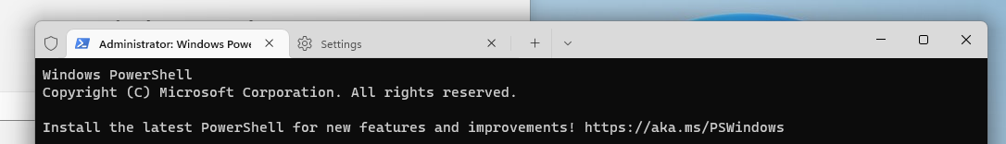
      2. Give it a try. Enter  
         Set-ExecutionPolicy -ExecutionPolicy Unrestricted
      3. Now enter   
         Get-ExecutionPolicy
         1. What is the resulting output? Unrestricted
   3. You can also start an administrative PowerShell from the taskbar if PowerShell is running.  
      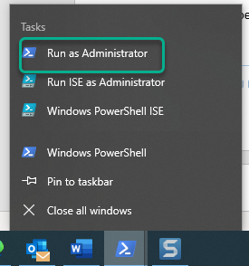
   4. Finally you can start an administrative PowerShell by using the Shift+Ctrl then clicking on the PowerShell icon in the taskbar or Start menu. Give it a try.
3. Start by running PowerShell
   1. If you type PowerShell either in the Start Menu or in a command prompt it will start Windows PowerShell.
      1. Give it a try.
4. Finally, you can run PowerShell by selecting it from the Quick Link
   1. Open the Quick Link menu by Right-Clicking on the start menu, or pressing Windows + X  
      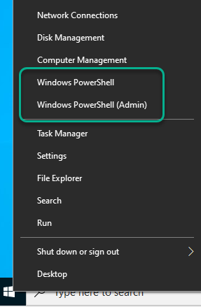
      1. Give it a try.

# Task 2—Make PowerShell easier to start

Since you will be using PowesShell a lot you might want to make it easier to start.

## Steps

1. Pin PowerShell to your taskbar and to your Start Menu.
   1. From the Start menu  
      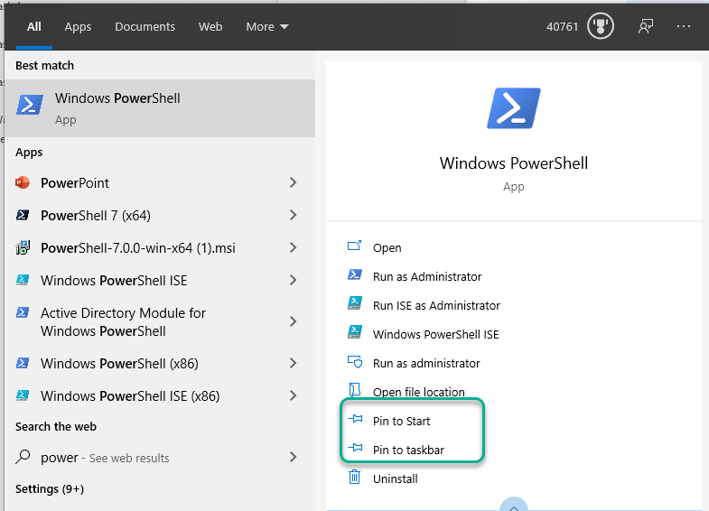
   2. You can pin PowerShell to the taskbar, from the taskbar, if PowerShell is running  
      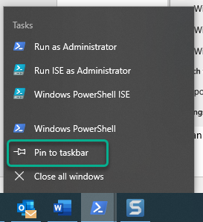

# Deliverable

Upload this document with completed answers to i-learn.